## **Project “Modell Alpha” 1-Page GDD**

*Chandler Bing and Deadpool will love this game* 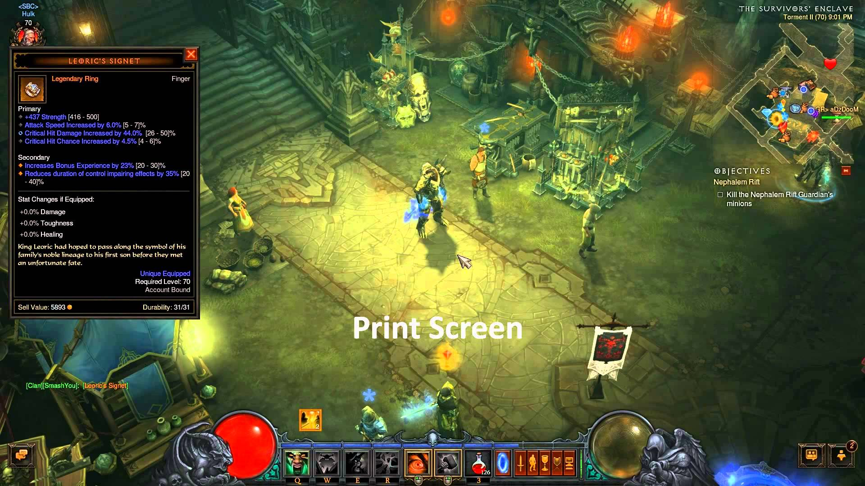

**Genre:** Third Person, Fixed Camera (for now), RPG  
**Target Audience:** T (Teen)

**Controls:** LoL inspired control scheme + Controller Support (to be implemented differently from KB+M, will be implemented after basic KB+M mechanics are ready)

**Thematic Setting:** medieval inspired with futuristic bits, unexpected design decisions (like enemy size and color scheme)

**Tech Stack:** Unity 2017, Blender, Photoshop CS2, Audacity

**Platform(s):** PC, Windows (can we do mac for MacKenZ?)

**Game Moment:** Movement from point A to point B while giving and taking damage using attacks

**Game Summary:** In this game, the player must assume the mantle of the “Sentinel” and protest The Realm from the threats of the Other World: forces of evil who aim to overtake The Realm and remake it in their own dark image. The game is set in a medieval era with certain 21st century elements (due to dimensional breaches and leaks in Time). Gameplay is very similar to Diablo (almost like a watered-down version of the game).

**Core Player Experience: Surprising, Sarcastic, Intense**

**Central Theme:** A relentless hero who lacks self esteem and is kinda sarcastic

**Design Pillar:** Put the hero in difficult situations, use wit and tools to win

**Anticipated Remarkability:** Sarcasm, action, player feedback

**Anticipated Steam Early Access Launch date:** August 4, 2018 (delayed from July 17, 2018))

**Feature Development Priorities: A polished, finished demo level**

**Comparative Products:** Diablo 3, Torchlight 2

**Health and Design Philosophies:**

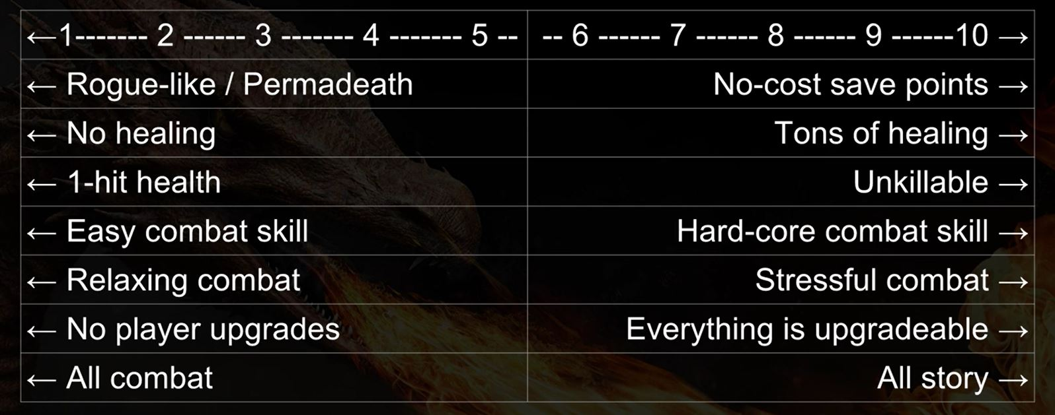

**Death management system:** Rogue like (death means you restart the game/level). Keep levels short.

**Healing:** Hold a button to heal, healing rate is such that healing while in combat will result in a slightly delayed death. Heal prompt appears when health is at about 30%

**Health levels:** Forgiving, death comes somewhat later. Near brute levels of health.

**Combat skill:** Beginners to intermediate level skills (for Brutes and Bosses).

**Combat Design:** Slightly challenging, need to evade and dodge along with attacking.

**Upgrades:** Boost attributes and (maybe) add new skills.  
**Lean towards:** More towards core combat, but a small story to keep things interesting.

Stat Sheet: https://docs.google.com/spreadsheets/d/1xpPusDjEatUJLLt8BOa7suODnX1R7NMYPWJ6uducxGc/edit?usp=sharing